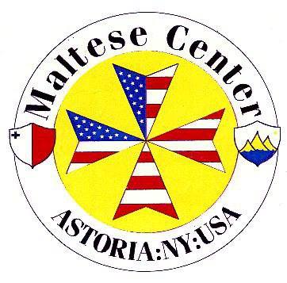
Application for The Maltese Center Membership
The Maltese Center 27-20 Hoyt Avenue South, Astoria, New York 11102 TEL 718-728-9883 www.themaltesecenter.com
New Member……..Renewal…….
*Each applicant over the age of 18 must fill out an application
Annual Member (18 and older) $120/YR ……

Title Mr/Mrs/Ms……… First…………………….................... Last……………………………………………
Spouse/Partner*………………………Children/Ages*…………………………………………………………….. *enter None if N/A
Address……………………………………………………………..Apt……. City…………………………….State………Zip Code……………
Home Tel……………………….................................. Mobile Tel………………………...........................
E-mail…………………………..................................... Date of Birth…………………………………………..
*Please be advised some Center correspondences will be sent out to member via email unless requested to be posted by mail.
Are you a? Senior …….. Veteran ……. Disabled…… Please provide proof with photo ID
Have you previously been a member of the Maltese Center? Y…... N…... If yes, what year?................
Are you related to a Maltese Center member or do you have a sponsor? Y…......N…......
If yes, full name of member/sponsor……………………………………………… Relationship………………………................
If you have no sponsor or no relation to a MC member, please verify your Maltese lineage/heritage and may also be subject to an interview by the Committee or a Committee Member.
Statement:
Membership Declaration
I hereby apply for membership of The Maltese Center and understand and by signing this form I agree that I am bound by The Maltese Center current Constitution and By-laws and the Center’s Code of Conduct. I agree that the continuation of membership is subject to my compliance, at all times with this declaration. I attest all statements and information to be true on this application. I understand that if I violate the Constitution and By-laws, Code of Conduct, and/or make false statements could result in termination of my membership. I understand my membership Is not valid until my application has been accepted by the Committee. The Committee has the final decision to accept or deny your membership application.
Name Signature Date
How to Pay if approved
CASH In Person at The Maltese Center CHECK Payable to: The Maltese Center PayPal
Office Use Only Membership Accepted: Y | N Date Paid: Card Received: Y | N

